Group: OpenCrowd

Software: LettuceBuy

User Documentation

1. Purpose

The intended purpose of this document is to provide new users with a well-organized set of pictures in order to make it easier for them to navigate through the website.

1. Step by Step Instructions for Client

The url for the currently running website is lettucebuy.zapto.org and the very first page should look like:

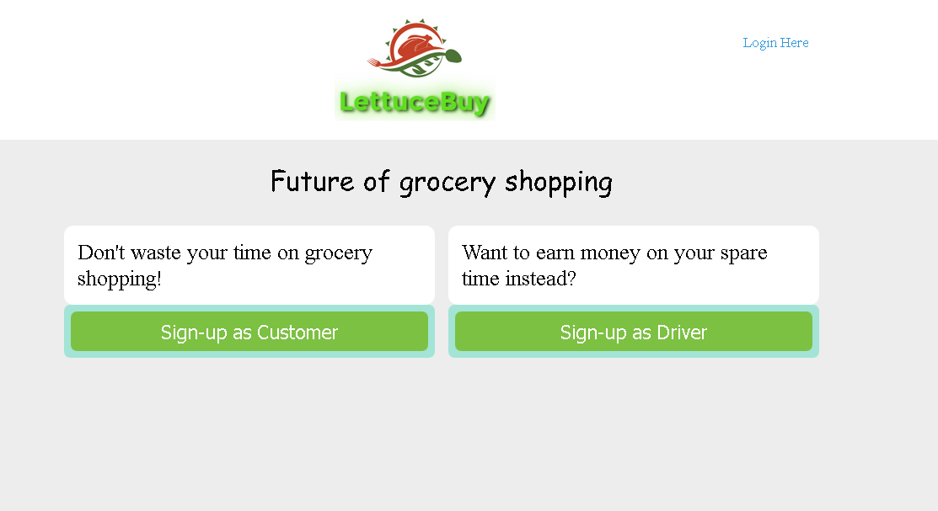

Figure 1

As a new user, the very first action that one should take is register an account on the website. Press “Sign-up as Customer” button in order to be redirected to the register page and fill out all of the required forms. This is a secure registration as you are asked to choose a security question and the password will be encrypted upon registration. If the username you typed is the same as someone else registered on the website, you will be prompted to enter a new one. Otherwise, you will be redirected to the Login page which should look like this:

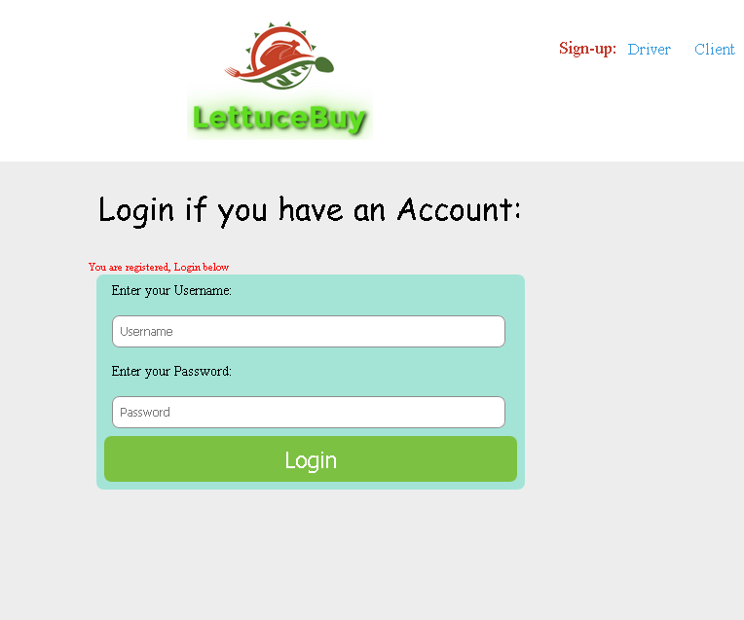

Figure 2

Here you will be asked to enter your username and password and will be redirected into the main page where you can input a shopping list if the login credentials are correct. The main page for clients looks like the following:

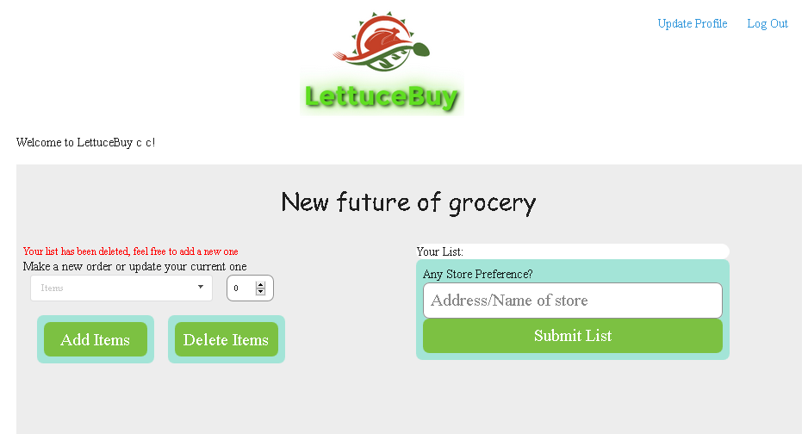

Figure 3

Here you can either click on the drop down list and add items into your cart or simply type in the text box and suggestions will be given to you based on what is in the database. Your current shopping cart will be displayed above the store name text box. Note that you may not add item that does not exist inside the database, so if you require something that is not listed, simply call your driver and inform them that way. You may enter a store name or address if you have a preference or you may leave it blank. The shopping cart however may not be left blank. Once you press “Submit List”, your list is uploaded onto the database with an ID associated to you and you will still have a chance to add or delete items from your list. In the current main page, you are able to update your credentials except for password and username.

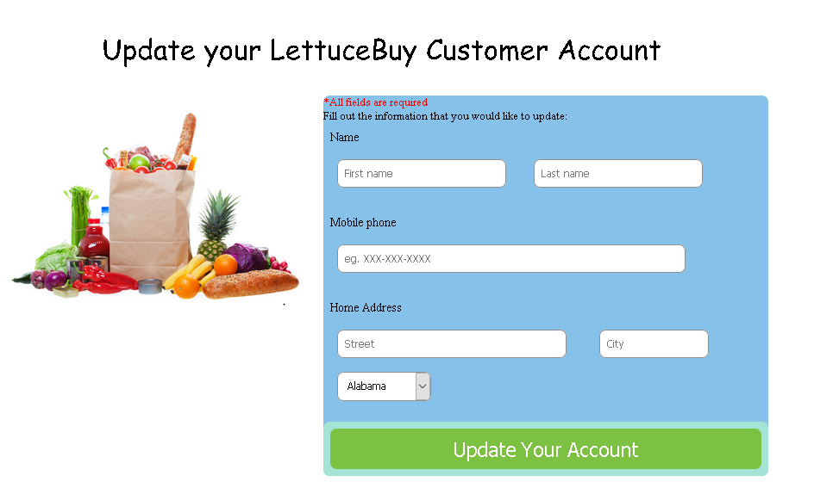

Figure 4

Figure 4 shows a simple interface of updating your current profile information. After going back and submitting your list, you will be redirected to a similar looking page except that drivers are able to see your list and can pick it at any time. Once picked you will be unable to add or delete anything from your list.

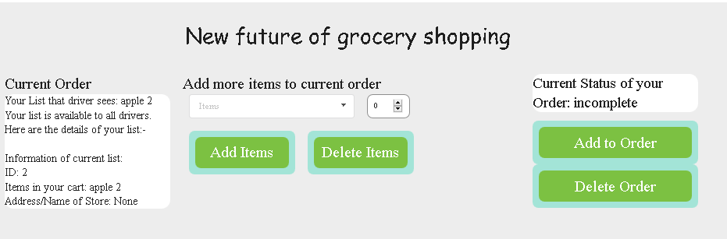

Figure 5

Information regarding your list is being displayed on the left side and a “Delete Order” button is now available. Pressing that button will simply remove your list from the pool and redirect you back to the previous page where you came from. You can also see the status of your current list. As long as it is ‘incomplete’, you are free to make changes.

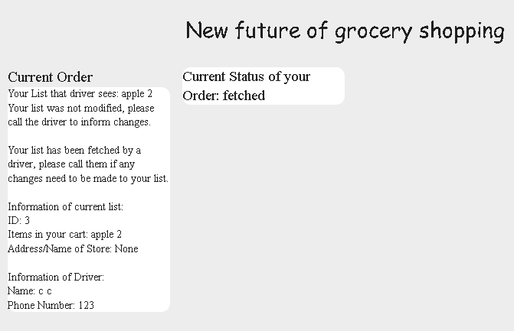

Figure 6

Once a list is fetched, one should see this and the status will change based upon whatever the driver presses on their end. Information regarding driver and their phone number is available if changes to the order need to be made.

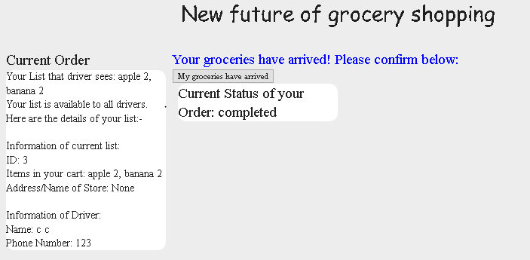

Figure 7

You should see this once the driver has finished delivering the groceries and confirms it on their end. They cannot do anything until you have confirmed it on your end that you did in fact receive the intended groceries by pressing the “My groceries have arrived” button. By pressing the button, you will simply be redirected back to Figure 5 to submit a new order or logout.

1. Step by Step Instructions for Drivers

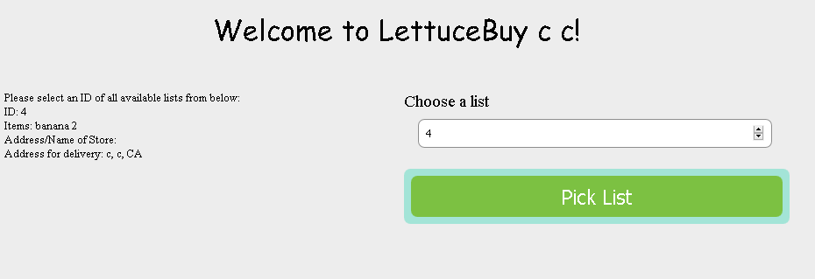

Figure 8

The drivers may also update their current credentials with the exception of username and password as well as the security questions. Here they will also see all of the current lists that are available for picking. To select a list, simply type the ID number an ID number to pick it. Invalid ID numbers will not work.

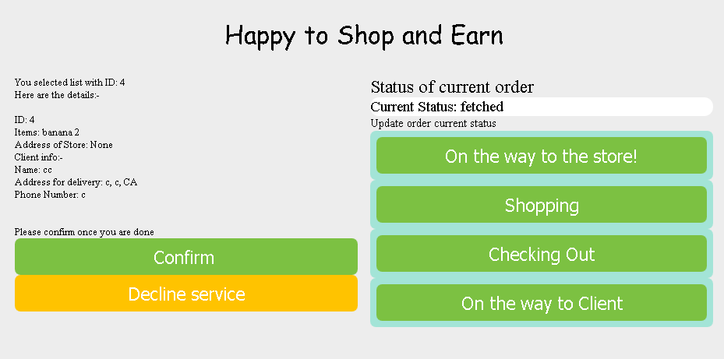

Figure 9

Once a list is picked, you will be redirected to another page showing client info as well as the list info. Here you are now expected to go and buy groceries. If for some reason there is a cause to drop the list, simply press “Decline service” and you will be redirected back to the previous page while the client’s list will be placed back into the pool of available lists. You are expected to press the buttons that change the status of the current order to inform client which phase you are in of grocery shopping.

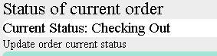This is what it would look like if any of the buttons are pressed.

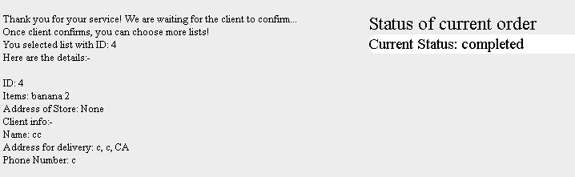

Figure 10

Once you press “Confirm”, all buttons regarding the status of the order will disappear and the status of the order will be changed to ‘completed.’ You may not do anything until the client confirms the fact that they did receive the groceries they ordered. Once they confirm it on their end, you will simply be redirected back to Figure 8 where you can pick another list to work. This marks the end of a transaction and is as far as the website goes.

1. Current Known Bugs

All known bugs have been fixed for v1.0 release. Before this, there was a bug that would not allow users to re-submit a new list after one transaction was completed but was fixed on 12/14/2016.